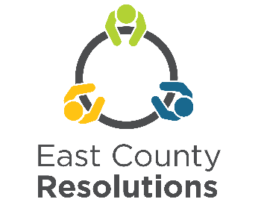 | Conflict Management Training  March 11th - 13th, 2026  Application due Feb. 25th, 2026

This 15-hour Conflict Management Training is held over three days; Wednesday, Thursday and Friday. Participants must attend all training days as each builds on the prior days’ lessons. The training is held virtually by Zoom.

Schedule: | Wednesday, March 11th, 9:00-3:30 p.m. Thursday, March 12th, 9:00-3:30 p.m.  Friday, March 13th, 9:00 a.m.-1:00 p.m.
Please fill out this application, answer the questions and send them with attached pages to be received by February 25, 2026.

Name:

Address:

Phone number: Day Cell

E-mail address:

What cost option are you applying for? (Please check one box)

❑ $400 training at full cost
❑ $250 training with commitment to utilize the skills as a community leader,
❑ $100 I am applying for 1 of 4 scholarships as a community-based organization that provides direct services to vulnerable and underserved populations in east Multnomah County (Fairview, Wood Village, Gresham, Troutdale, Unincorporated east Multnomah County).
❑ No cost I am a City of Gresham, Fairview, Troutdale, Wood Village employee

Hardship waivers are available for those living or working in our service area.

Please answer the following questions if you are applying for a reduced rate scholarship.

- Which area is you or your agency located? (Please check one)
☐Troutdale ☐ Wood Village ☐Gresham ☐Fairview ☐Unincorporated East Multnomah County

- Please explain how your agency serves vulnerable and/or underserved communities in east Multnomah County or how you, yourself represent a vulnerable and/or underserved community.
_______________________________________________________________________________

_______________________________________________________________________________

_______________________________________________________________________________

_______________________________________________________________________________

_______________________________________________________________________________

- How do you plan to utilize the skills you gain in this training to support and benefit the community?
_______________________________________________________________________________

_______________________________________________________________________________

_______________________________________________________________________________

_______________________________________________________________________________

_______________________________________________________________________________

3. How did you find out about this training?

_______________________________________________________________________________

4. The following information is voluntary and useful to us in forming a balanced group of trainees.

Age: _______ Gender: _______ Race/Ethnic group: __________________

